44.59: 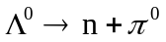
a) 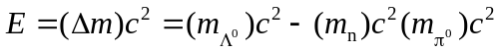
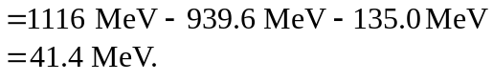
b) Using conservation of momentum and kinetic energy; we know that the momentum of the neutron and pion must have the same magnitude, 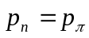
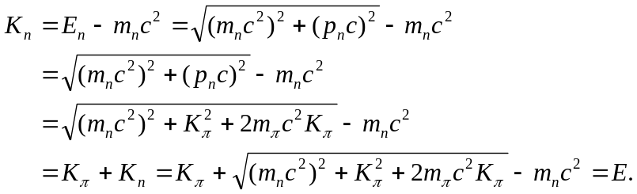
( Collecting terms we find :
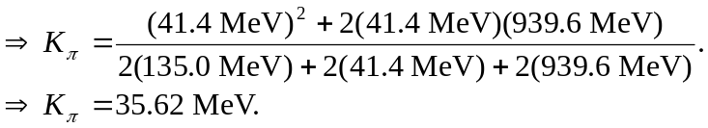
So the fractional energy carried by the pion is 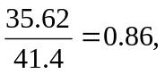and that of the neutron is 0.14.

